Social ties are good for your health

Stanford University—BeWell@Stanford
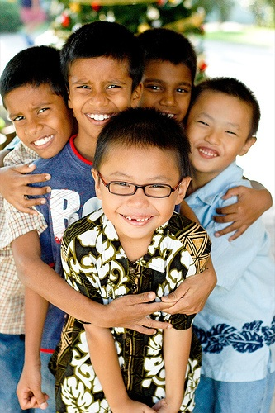
We may all know that relationships with friends and family add immensely to the quality of life. But did you also know that such social ties can help us live longer? BeWell talks to Cecile Andrews, author and a former affiliated scholar with the Clayman Institute for Gender Research, about why it is healthy to forge connections to others.
Being connected to others is nice, but is it important?
In our crazy society, social ties are pretty far down on our “to do” lists, but connection to others is turning out to be more important than we thought. Studies indicate that “social capital” is one of the biggest predictors for health, happiness, and longevity. The problem: we often do not recognize the importance of social connection. Our culture values hard work, success, and wealth, so it’s no surprise some of us do not set aside enough time for social ties when we think security lies in material things rather than other people.
Olds and Schwartz (Associate Clinical Professors of Psychiatry at Harvard Medical School) argue in The Lonely American that loneliness is often mistaken for depression. Instead of connecting with others, we consume a pill. Being lonely is outside of our individualistic world view so we don’t even see it as a problem.
Harvard’s Robert Putnam writes about social capital in his book, Bowling Alone, and shows how social ties are not only important for personal well-being, but also for our democracy. To paraphrase Putnam, “the culture in which people talk to each other over the back fence is the culture in which people vote.” Apparently, when you feel part of a group, you’re more likely to contribute to it — such as by voting.
UC Berkeley’s George Lakoff has said that we can only bring about progressive social change by evoking empathy. You can’t get people to change by loading them up with facts or shaking your finger at them. You must talk to others with respect and caring — and then you connect. Social capital is thus central to progressive social change.
Social capital is important for the planet as well. Environmentalist and author Bill McKibben says that we won’t have sustainability without community. Until we see other people as our main source of security, we’ll keep turning to things, using up oil and other resources and heating and polluting the planet. Until we have community in our neighborhoods, we’ll keep going to the mall for our evening’s entertainment.
Does research show convincingly that social ties really improve health?
Yes, and there are many studies, but it is difficult to determine the quality of the research unless you examine it closely. Some studies focus on short-term health benefits such as reduced incidence of colds and flu. Other research looks at longevity, alleging that the number of friends correlates with longer life. Still other studies have found that people have better survival rates for diseases when they have social support. Not long ago I heard a cardiologist compare social isolation to smoking, saying that loneliness is the new tobacco.
One of my favorite books is The Loss of Happiness in Market Democracies, by Robert E. Lane, Professor Emeritus of Political Science at Yale. His book brings together much of the research done on social capital over the last several years and shows how social ties not only affect our personal health, but also our societal health. He observes that as prosperity in a society increases, social solidarity decreases. Happiness not only declines, people become more distrustful of each other as well as their political institutions. Lane argues that we must alter our priorities; we must increase our levels of companionship even at the risk of reducing our income.
I’ve often wondered why we require so many studies to prove that we need each other and that it is important to care for each other. I would simply call it wisdom.
What if I am not "connected"? Are there simple ways to start building relationships?
Putnam says that if you don’t belong to a group and you join one now, you’ll cut your chance of dying in half for the next year. (You probably don’t have a big chance of dying anyway, but I kind of like this study because it gets people’s attention.) If you join a group, do more than just send in your dues. Come together face to face, such as by volunteering for committees or agreeing to work on projects. By the same token, organizations shouldn’t just hold dull meetings; they need to have parties and potlucks as well as conduct business in an interesting manner.
You also have to talk to people. Introduce yourself, ask questions, tell stories, be interested! I heard a startling recommendation: if you want to find a romantic partner, you should talk to five new people a day!

